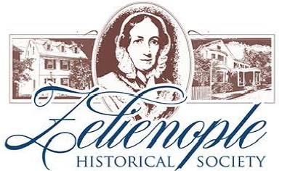
243 S. Main St. Zelienople, PA 16063
724-452-9457 ZelieHistory.org
Membership
Membership in the Zelienople Historical Society is open to anyone interested in helping the Society reach its goals of preserving and sharing the history of the Zelienople.
If you would like to join us, your membership includes:
- Newsletters
- Free admission to Passavant House and Buhl House during regular tour hours
- Use of the Lester Mohr Library and file resources for genealogical and other historical research projects
- Attendance to member meetings
- Voting on Society business
- Priority on rentals
- Volunteer opportunities
Please return this completed form with a check to Zelienople Historical Society, 243 S. Main St., Zelienople, PA 16063.
Name: ___________________________________ Date: ___________________

Business Name: ____________________________________________________

Address: _________________________________________________________

City/State/Zip: _____________________________________________________

Phone: ___________________________________________________________

Email: ___________________________________________________________
Membership Options  ___ Individual $20  ___ Family $35  ___ Student $5  ___ Business $50  All memberships are annual and are on our fiscal year July through June. | I would like to help with:  ___ Acquisitions  ___ Budget and Finance  ___ Docents and Tours  ___ Endowment Fund  ___ Buildings and Grounds  ___ Library and Research  ___ Membership  ___ PR and Advertising  ___ Ways and Means | I would like to include a tax deductible donation.  ___ General Fund  ___Memorial  ___Other (specify)

